**R: Intermediate**

**Datafiles**

For these exercises, download the files:

“Business Analytics – Week 8 Instructions.doc”

“Business Analytics – Week 8 oj.xls”

**Review: Installation of R**

R is a free downloadable package capable of performing sophisticated statistical analysis and data mining. The software is already installed on the classroom laptops. To install on your own personal computer:

1. Go to the website: <http://cran.r-project.org/bin/windows/base/>
2. For a Mac, go to <http://cran.r-project.org/bin/macosx/>
3. Click on Download R 3.0.3 for Windows
4. Click on Run, and follow the install instructions

**Starting R**

1. Click on the Start button in the lower left corner of Windows
2. Click on All Programs, then click on the R folder, then R

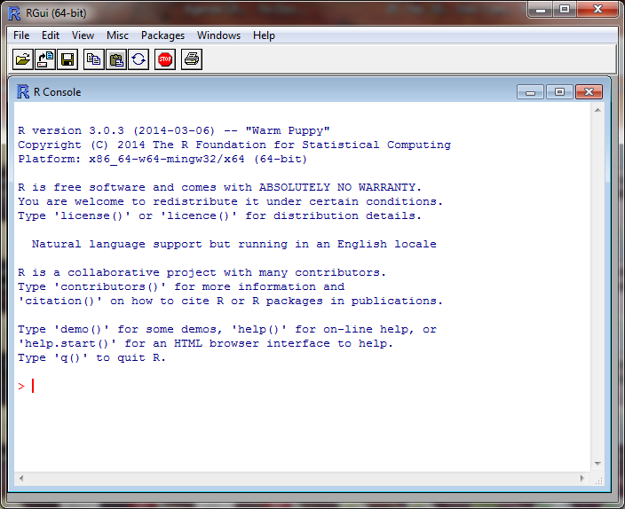

This is the command line screen. You can enter commands, but need to know the syntax. There is a simpler approach to running R, called Rcmdr (R Commander). If you are running a Whitman computer, Rcmdr is already installed. If not, you need to install it.

**Installing R Commander**

Follow these steps only if you don’t already have Rcmdr installed.

1. At the top of the screen, click on Packages
2. In the drop down menu, click on Install Package(s)
3. In the CRAN mirror, select the location closest to you; use USA (PA 1), then click OK
4. In the Packages screen, click on Rcmdr, then OK
5. When prompted to create a personal library, click Yes

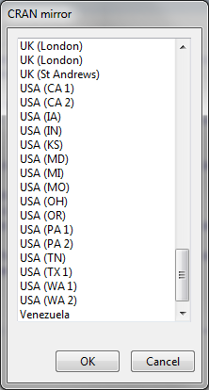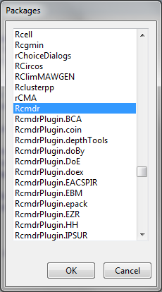

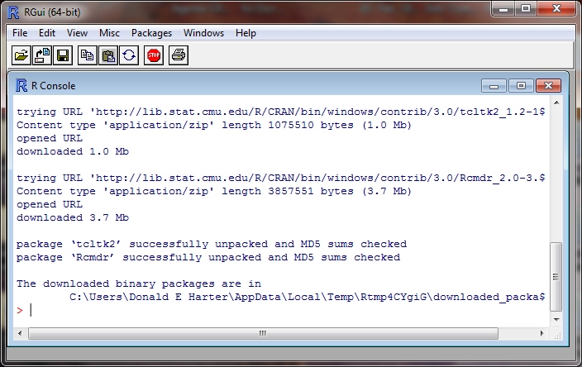

**Launch Rcmdr (R Commander)**

Rcmdr is a graphical user interface (GUI) that is easier to use than the command line. To launch Rcmdr:

1. Type library(Rcmdr)
2. If you receive a warning message that some packages are missing, it will ask if you want them installed. Click Yes.
3. On the Install Missing Packages screen, click OK
4. R will install the necessary software
5. The R Commander screen will appear

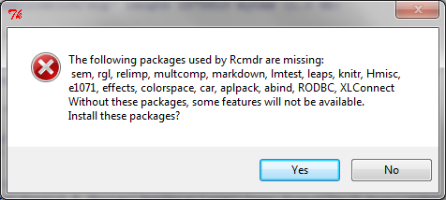

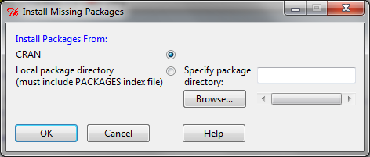

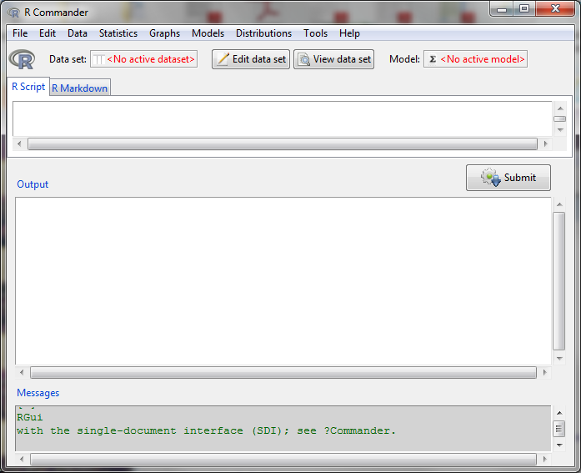

**Modeling Background (Correlation & Regression)**

Identifying data relationships is key to modeling behavior of customer, student, and corporate data. First, let’s consider two variables and the relationships between them. When comparing two data variables, you can have:

1. No relationship between the variables
2. A positive relationship (when one variable goes up, the other goes up)
3. A negative relationship (when one variable goes up, the other goes down)
4. A curvilinear relationship (a non-linear relationship

Examples of these, from The Research Methods Knowledge Base by Trochim & Donnelly (2007):

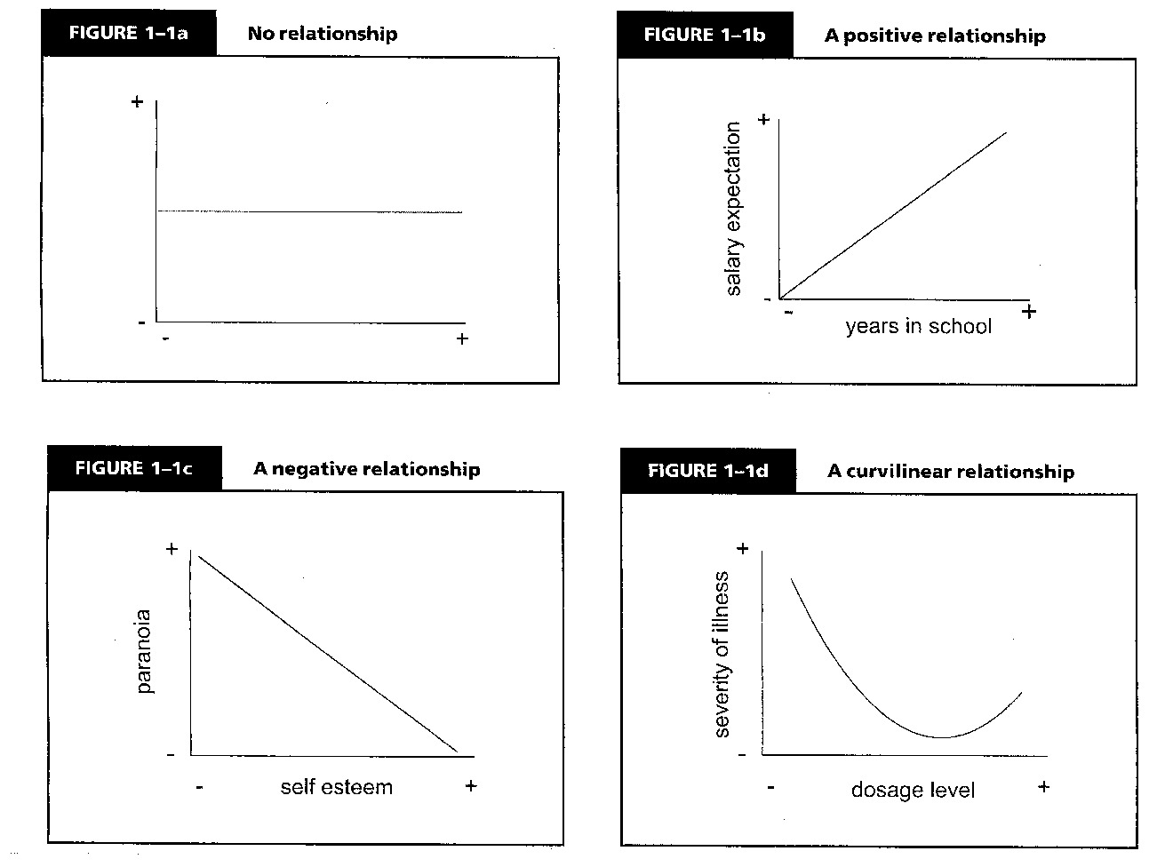

**Regression**

Linear regression is a technique that calculates the relationship between a dependent variable Y and one or more independent variables, or X’s. Assume that you have data similar to the picture below.



You can calculate a regression trend line based on the data. This dashed line represents which is the estimate of the Y equation.



The vertical distance between the line and the data point is called the residual or error term.

**Regression Diagnostics**

There are several assumptions of linear regression:

1. The relationships are linear
2. The X variables (explanatory variables) are not correlated
3. Distribution of residuals
   1. The error terms have constant variance
   2. The errors terms are not correlated
   3. There are no outliers

**Assumption #1: the relationship is linear**

Let’s examine each of these assumptions. In the pictures below, the left picture has data with a linear relationship, the right picture had non-linear data. Linear regression can only be used on data with a linear relationship. Transformations can be used to transform non-linear data into linear data. For example, exponential data like the data on the right can be converted into a linear relationship by taking the logarithm of both the Y and X variables.

|  |  |
| --- | --- |
|  |  |

**Test for Linearity**

The Ramsey Regression Equation Specification Error Test (RESET) (1969) to test for linearity

**Solution to non-linearity**

The best solution for non-linear data is to transform the data using logarithms, squares, square roots, or inverses (1/variable). There are more advanced techniques which can assist in determining the correct transformation (Box-Cox for the Y variable; Box-Tidwell for the X variables).

**Assumption #2: The X variables are not correlated (no multi-collinearity)**

When including more than on explanatory or independent variable (i.e., X variable) in an analysis, you must ensure that they are not related to each other. If you plot the X variables, you should see no pattern, such as the picture on the left between variables X1 and X2. If you see a relationship, such as on the right between X2 and X3, then multi-collinearity exists.

|  |  |
| --- | --- |
|  |  |

**Test for Multi-collinearity**

The Variance Inflation Factor test of correlated explanatory variables

**Solution to Multi-collinearity**

If two or more variables are collinear (highly correlated), there are three solutions:

1. Combine the variables, for example, take an average of the variables
2. Drop one of the variables
3. Use factor analysis to combine variables

**Assumption #3a: The error terms do not have constant variance (Heteroscedasticity)**

The residuals (error terms) of a regression must have constant variance over a range of X values. If the size of the error terms depends on an X value, this is called heteroscedasticity. Heteroscedasticity is often caused by performing a linear regression on non-linear data. In the charts below, there is no relationship between the X variable and the error term. On the right, the residuals or errors are heteroscedastic; the size of the error is dependent on the X value.

The picture below shows heteroscedastic residuals. Notice that the variability of the errors or residuals tends to grow larger for larger values of X. The picture on the right has lines added indicating the general growth in variability.

|  |  |
| --- | --- |
|  |  |

**Test for Heteroscedastiticy**

Breusch-Pagan test of heteroscedasticity

**Solution to Heteroscedasticity**

Heteroscedasticity is often caused by performing linear regression on non-linear data. Generally, solving non-linearity problems with transformations reduces or eliminates heteroscedasticity. If the problem is not completely resolved with a transformation, additional advanced techniques including Huber regression can correct lingering issues.

**Assumption #3b: The error terms are not correlated (Serial Correlation)**

When dealing with data over time, it’s possible for the error terms from one time period to be highly correlated with the previous time period. This is called serial correlation. The error terms or residuals will have a pattern that is not random, such as in the picture below.



**Test for Serial Correlation**

Durbin-Watson test of serial correlation

**Solution to Serial Correlation**

To correct for serial correlation there are a number of techniques in time series, including rho differencing and ARCH.

**Assumption #3c: There are no outliers**

An outlier is a data point that is significantly different from other data points. Outliers are often the result of unusual circumstances or data entry errors. The data below has an outlier.



**Test for Outliers**

Bonferroni outlier test

**Solution to Outliers**

If the data point is clearly an outlier, you can drop the bad data point, but mention in your analysis that you dropped outliers.

**Download Datasets**

To access some excellent data sets used in the book “Data Mining and Business Analytics with R,” by Johannes Ledolter:

1. Go to the website:

http://www.biz.uiowa.edu/faculty/jledolter/DataMining

1. Click on Data Text
2. Right click on oj.csv, then save on your computer
3. Remember where you saved the file

The Business Analytics - Week 8 oj.csv (orange juice) file can be downloaded from the course website.

**Loading Data**

To load data into R:

1. Click on Data at the top of the screen
2. Click on Import Data > From text file …
3. Enter the name that you would like to use for this data set; type in oj
4. Change Field Separator to Commas, then OK
5. Click on the oj file, then Open

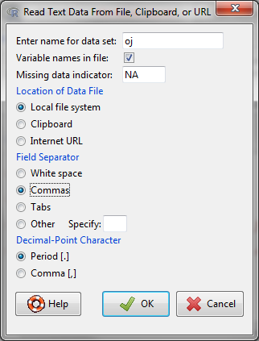

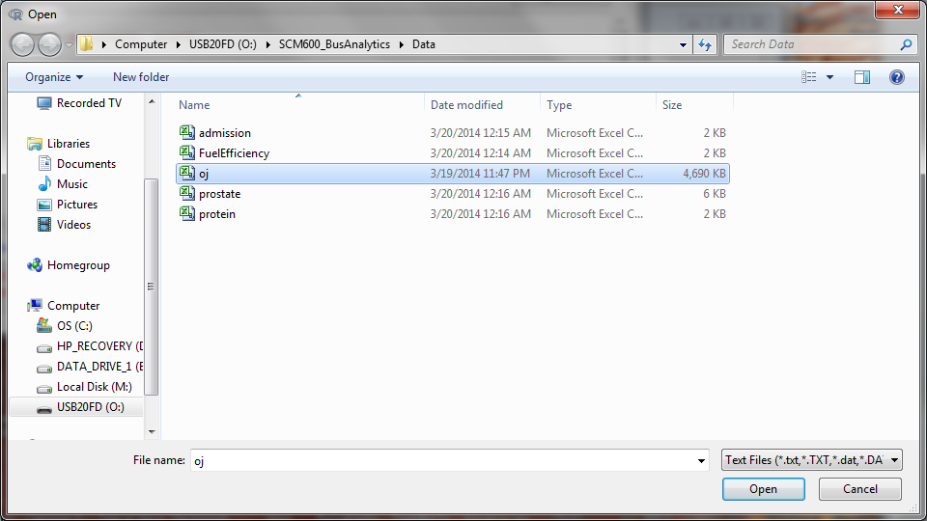

**Session 8.4: Regression and the RESET test for linearity**

Linear regression of the log of sales against age, income and price can be performed by:

1. Click on Statistics, Fit Models, Linear Regression
2. For response variable, click on logmove
3. For explanatory variables, hold down the control key and click on AGE60, INCOME, price
4. Click OK

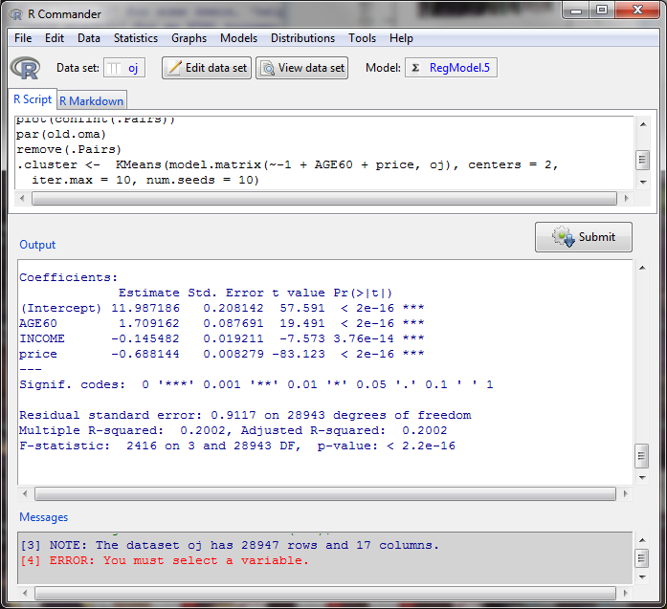

**Ramsey Regression Equation Specification Error Test (RESET) (1969) to test for linearity**

To test if your equation is linear:

1. Click on Models, Numerical Diagnostics, RESET test for Non-linearity
2. Click OK

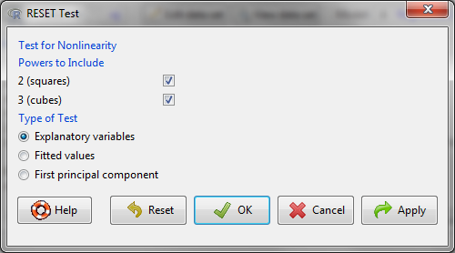

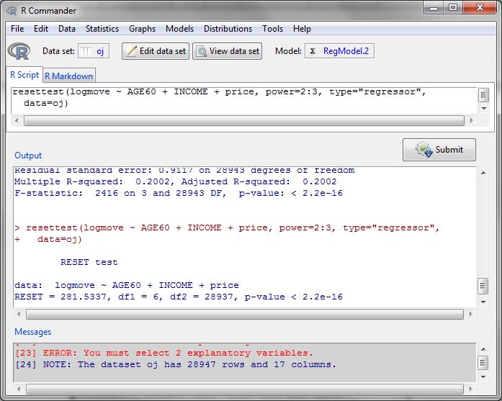

If the p-value is less than 0.05, then there is a non-linearity problem.

**Session 8.5: Variance Inflation Factor test of correlated explanatory variables**

To calculate the Variance Inflation Factor:

1. Click on Models, Numerical Diagnostics, Variance Inflation Factor

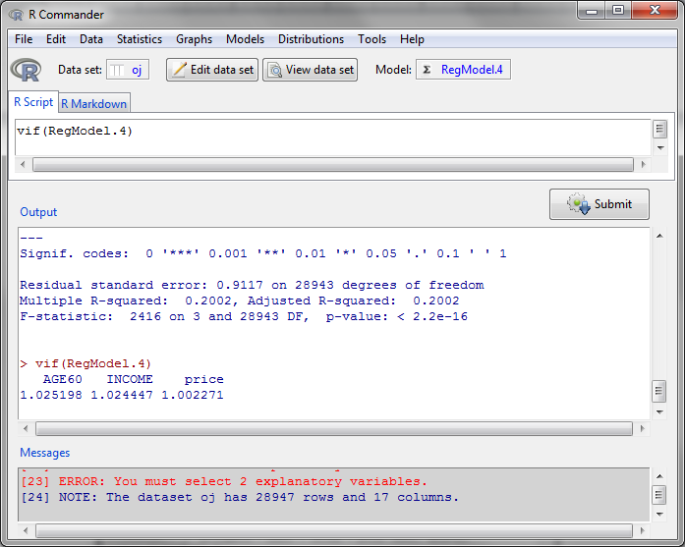

If the variance inflation factors are less than 10, then there is no multi-collinearity. If multi-collinearity exists, then drop variables or combine variables. Factor analysis is one technique for combining variables.

**Session 8.6: Breusch-Pagan test of heteroscedasticity**

Heteroscedasticity means that the error terms are vary depending on values of the explanatory variables. To test for heteroscedasticity:

1. Click on Models, Numerical Diagnostics, Breusch-Pagan test for heteroscedasticity
2. Double click on AGE60, INCOME, price
3. Click on OK

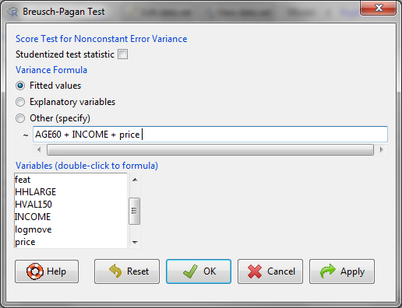

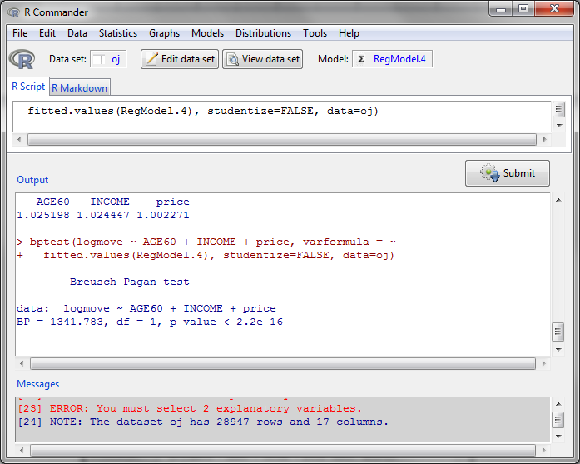

If the p-value is less than 0.05, then there is a problem with heteroscedasticity. Generally, this is a sign that the equation is non-linear.

**Session 8.7: Durbin-Watson test of serial correlation**

Serial correlation occurs when the errors terms are correlated. To test this,

1. Click on Models, Numerical Diagnostics, Durbin-Watson test for autocorrelation

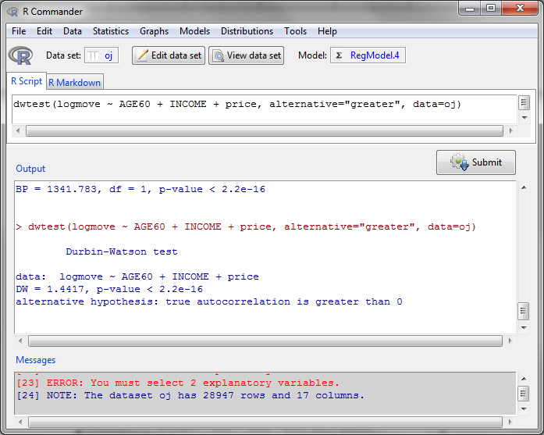

If the p-value is less than 0.05, there is a problem with serial correlation.

**Session 8.8: Bonferroni outlier test**

Outliers are extreme data points that can influence the results and lead to incorrect coefficients. To identify outliers,

1. Click on Models, Numerical Diagnostics, Bonferroni outlier test

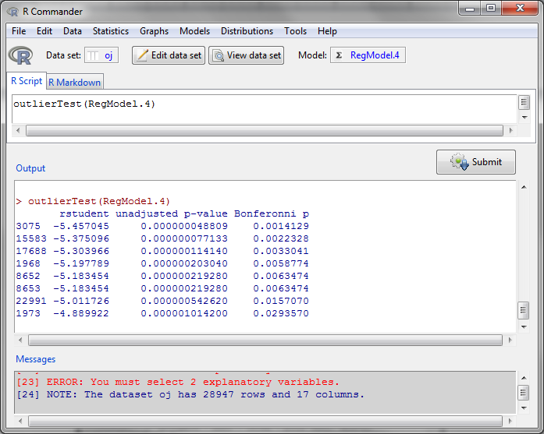

In this example, data points numbered 3075, 15583, 17688, etc., are outliers. It’s usually best to remove these data points from your data.

**Session 8.9: Data Mining**

Data mining tools allow you to explore in more detail groupings of data and more sophisticated analysis. Rattle is an add-in to R that facilitates data mining.

**Installing Rattle**

Follow these steps only if you don’t already have Rattle installed.

1. At the top of the screen, click on Packages
2. In the drop down menu, click on Install Package(s)
3. In the CRAN mirror, select the location closest to you; use USA (PA 1), then click OK
4. In the Packages screen, click on rattle, then OK
5. Type library(rattle)
6. Type rattle()
7. When it asks “Would you like Rattle to install …”, type yes
8. If you receive an error message about GTK+, then install GTK+ by clicking OK
9. If you receive an error message about XML, click Yes to install
10. Similarly for cairoDevice

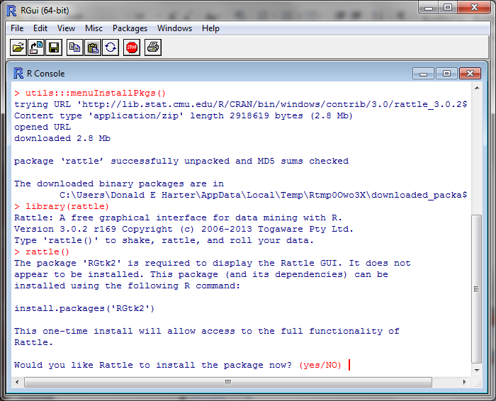

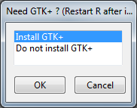

**Launch Rattle**

After Rattle has already been installed, you can always launch Rattle by:

1. Type library(rattle)
2. Type rattle(), press enter, then type yes, press enter

**Loading Data**

The package R has some built in data sets. To load data into R:

1. In the R Data Miner [Rattle] window, click on the Data tab
2. Check that Source indicates Library
3. Next to Data Name, use the drop down menu to select audit: rattle: Sample dataset
4. Click on Execute
5. This data set represents income tax audit data

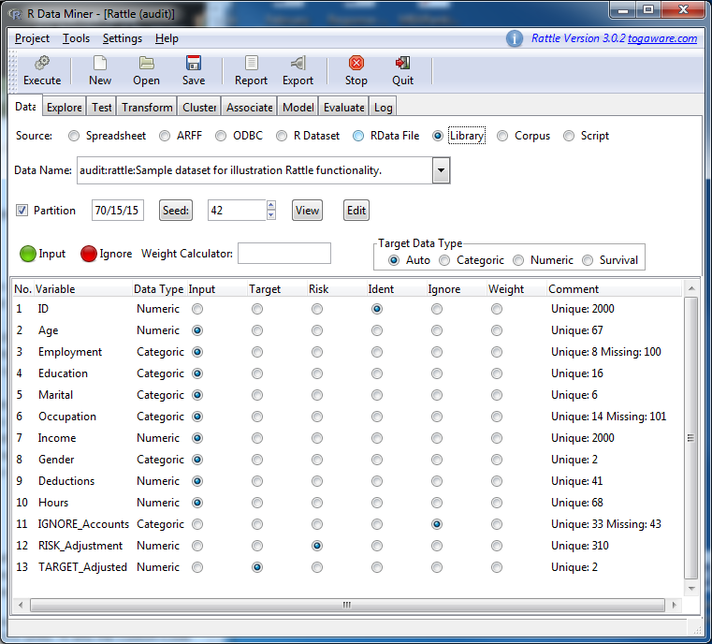

**Summary Statistics**

1. Click on the tab Explore
2. Check the radio button Summary
3. Click on Execute

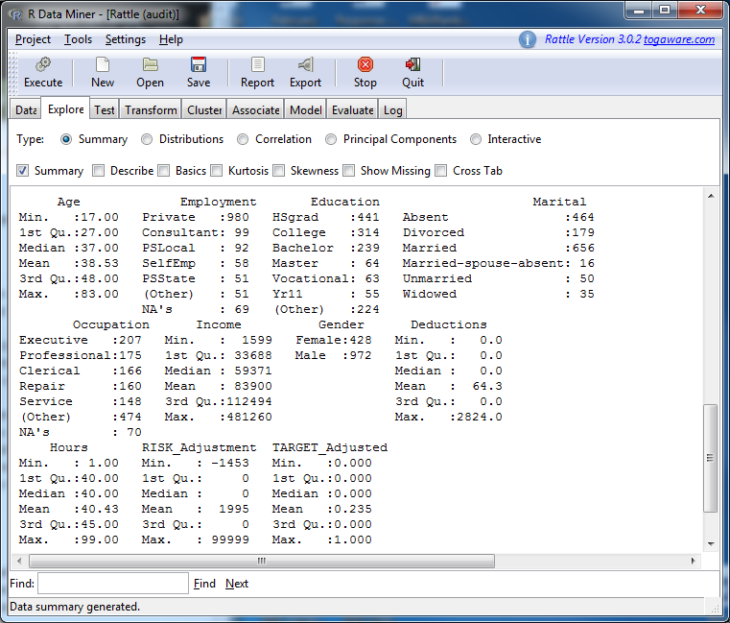

**Session 8.10: Benford’s Law – Detecting Fraud with Data Mining**

In auditing (accounting, financial audits, tax audits), there is a rule called Benford’s Law that specifies the frequency of the first digit in almost any financial number. For example, approximately 30% of financial numbers start with the digit 1.

The data set that was loaded describes 2000 income tax audits. To compare the result of income tax audits to Benford’s Law:

1. Click on the tab Explore
2. Check the radio button Distributions
3. In the line for Income, check the box under Benford
4. Click Execute

The Benford line is the expected frequency of the first digit of tax payers’ income. The All line is the frequency of the first digit of all tax returns filed for 2000 people. The 1 line is the frequency of first digits of income for tax payers who were asked to fix their tax returns. The 0 line is those tax payers were not asked to fix tax returns. The 1 line departs significantly from the Benford line.

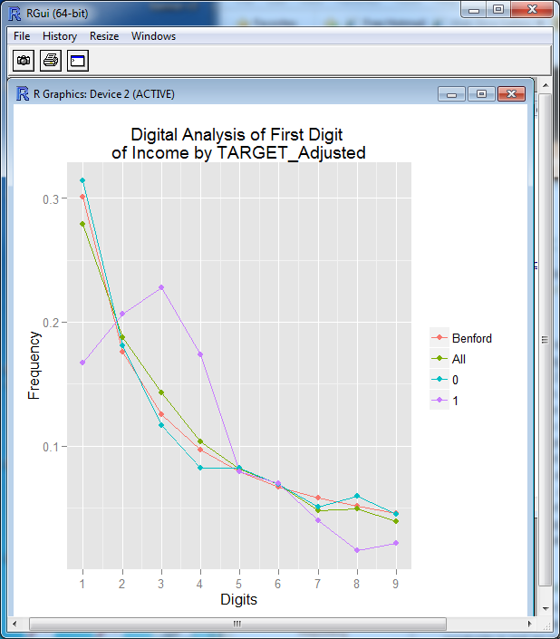

**Statistical Tests**

It appeared from the Benford curve that the distribution of tax violators (coded as 1) were different from non-violators. Let’s test the means of the two distributions to see if they are different.

1. Click on the tab Test
2. For Two-Sample Tests, click on the radio button T-test
3. For Sample 1, use the drop down arrow to select Income
4. Click Execute

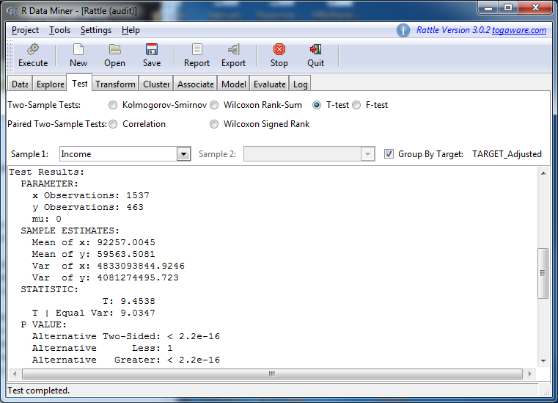

The X observation is for those coded as 0; Y observation for those coded 1. Look at the p-value for the test. Are the two groups different? What is the average income for each group? Which group appears to be misreporting their income more frequently? The higher or lower income group?

**Session 8:11: Decision Trees**

**Loading Data**

To load data into R:

1. In the R Data Miner [Rattle] window, click on the Data tab
2. Check that Source indicates Library
3. Next to Data Name, use the drop down menu to select weather: rattle: Sample dataset
4. Click Execute
5. This data set represents historical weather data

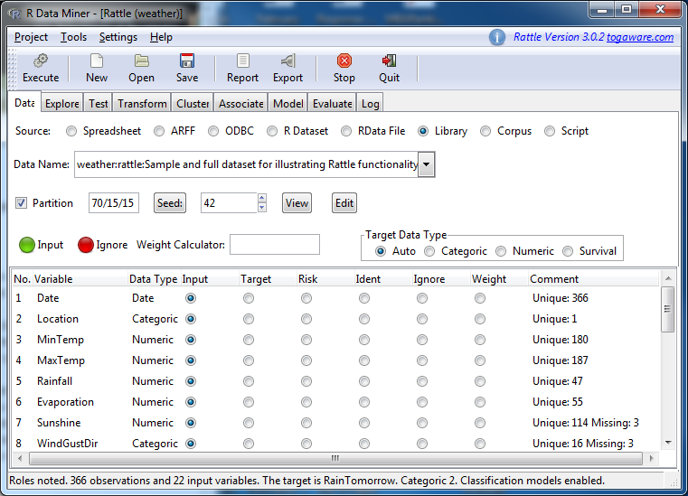

**Generating Decision Tree**

Create a decision tree to determine how to predict tomorrow’s weather.

1. Click on the Model tab
2. Check the radio button Tree
3. Click Execute
4. Click on the button Draw

The resulting decision rules to predict rain tomorrow are:

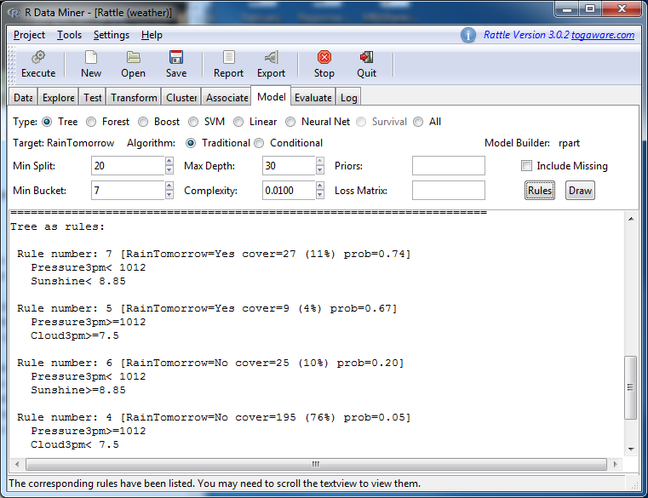

The decision tree is:

